**LED PROGRAM:**

#include <lpc17xx.h>

void delay(unsigned int ms)

{

unsigned int i,j;

for(i=0;i<ms;i++)

for(j=0;j<20000;j++);

}

int main()

{

SystemInit();

LPC_GPIO2->FIODIR = 0x00000000;

LPC_GPIO2->FIODIR = 0xffffffff;

while(1)

{

LPC_GPIO2->FIOSET = 0xffffffff;

delay (100);

LPC_GPIO2->FIOCLR = 0xffffffff;

delay (100);

}

}

**INTERFACE OUTPUT:**

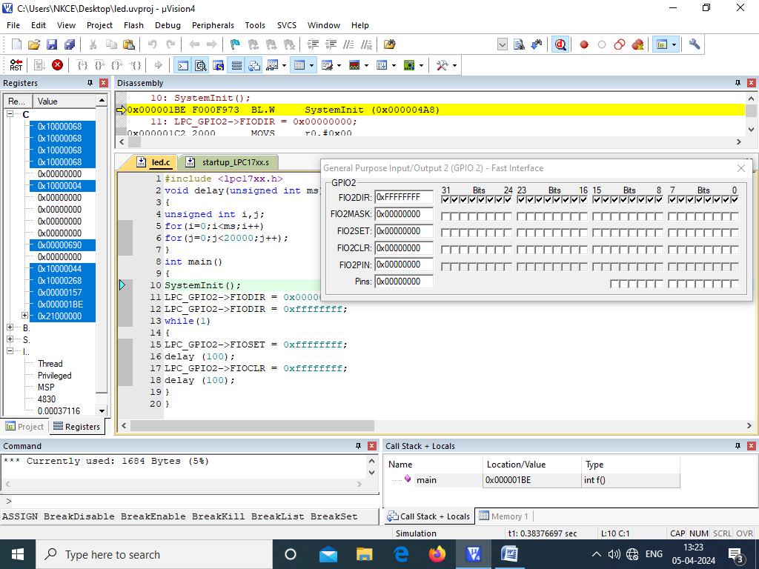

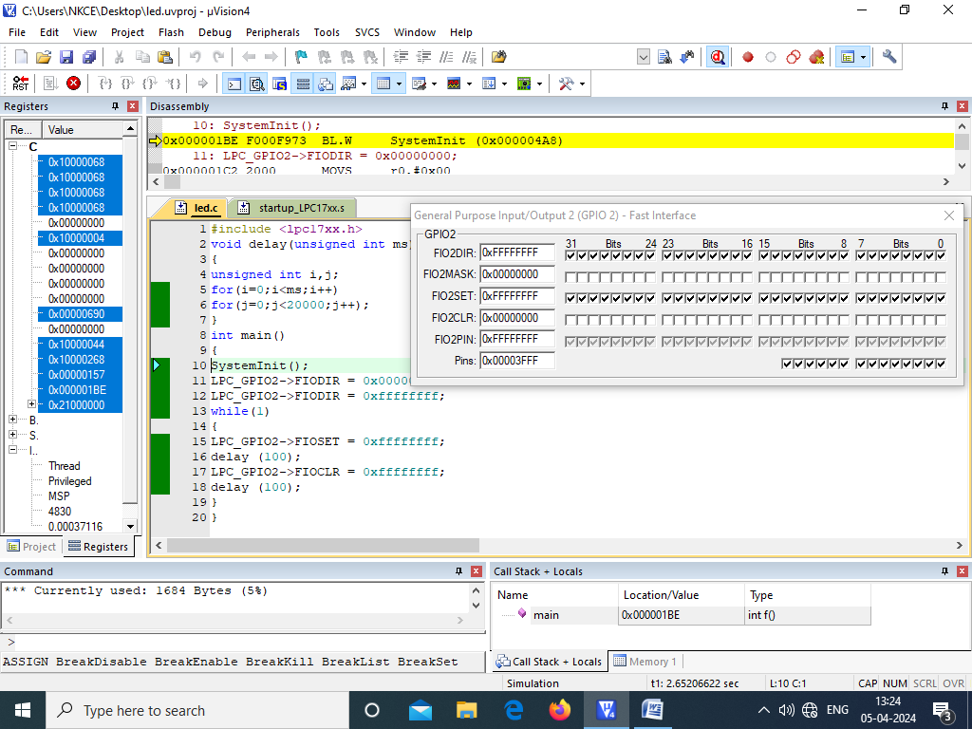

**LED IMPLEMENTATION:**

